Van Lang University

Software Measurement and Analysis course

**Viking Project - Customer Satisfaction Survey Report**

**Version number:** 1.0

**Author:** K14T01 – Team 01

**Team member:**

Duong Nguyen

Mung Nguyen

Binh Huynh

Hien Nguyen

Manh Nguyen

Table Content

1. Introduction 2
2. Measurement Method 2
   1. General Charts 2
   2. Survey Question 3
3. Recommend 3
4. **Introduction**
   1. **Overview**

We sent this survey to our five big customers 4 months after Viking release 1 shipped to find out how they were using the product, and how much they liked it

At the time we sent out the survey we had the 5 big customers and about 20 small (<20 users each) customers. We choose to not send the survey to the small customers because the large customers have thousands more users so they are whom we want to please the most.

* 1. **Purpose**
* To analysis and calculate Customer Satisfaction Index based on the Viking customer satisfaction data that is provided by customers.
* To provides the recommendations to improve customer satisfaction and software project.
* The data in this assignment collected by Viking customer satisfaction data.xls

This document provides data analysis tables after surveying and collecting customer’s suggestions for Viking product to report to the executive board

1. **Measurement Method**
   1. **General Chart**

Base on Viking project-Customer Satisfaction Survey data, we collect data and gather it in the form of the overview chart as follow:

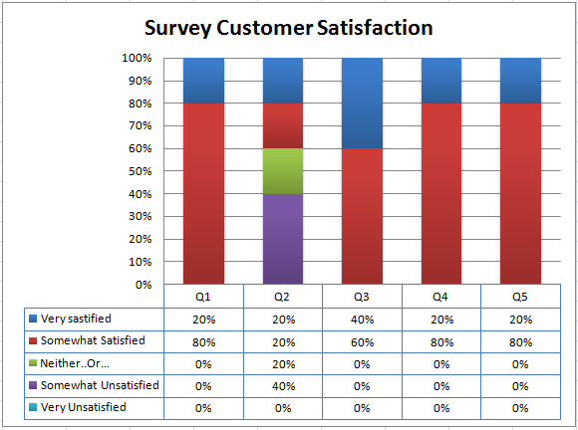

Figure 1: A general view of data collected from the survey

**2.2 Survey Question**

The following Table shows measure item that will used by Viking project to evaluate the customer satisfaction.

|  |  |  |
| --- | --- | --- |
| **Satisfaction Item** | **Question** | **Description** |
| Service | Q.1 | How satisfied are you with your purchase experience? |
| Q.2 | How satisfied are you with your support experience? |
| Quality | Q.3 | How often do you use the Viking software? |
| Q.4 | How satisfied are you with your user experience? |
| Q.5 | Overall, how satisfied are you with our software? |
| Q.6 | How often do you use the Viking software? |

The questionnaire in Table_1 uses a scale of 1 to 5 to measure the customer satisfaction level

|  |  |  |
| --- | --- | --- |
| **Score** | **Scale** | |
| 5 | Very Satisfied | At least once per week |
| 4 | Somewhat Satisfied | 2-3 times per month |
| 3 | Neither Satisfied nor Unsatisfied | Once per month |
| 2 | Somewhat Unsatisfied | Once per quarter |
| 1 | Very Unsatisfied | Once per year |
| 0 |  | Do not use |

The following table shows the formulas to calculate the Customer Satisfaction Index and its standard for each customer.

|  |  |  |
| --- | --- | --- |
| **Item Index** | **Formula** | **Objective** |
| Service Index (SI) | Service Index = (Q.1 Score + Q.2 Score)/10 | - Assess customer satisfaction on service quality.  - SI > 80% - high customer satisfaction |
| Quality Index (QI) | Quality Index = (Q.3 Score + Q.4 Score + Q.5 Score + Q.6 Score) /20 | - Assess customer satisfaction on product quality.  - QI > 80% - high customer satisfaction |
| Customer Satisfaction Index (CSI) | CSI = (SI*30 +QI*70) / 100 | - Assess customer satisfaction on Viking Project.  - CSI > 80% - high customer satisfaction |

1. **Recommend**

* Survey should be done on different age
* Should be focus on the main aspects of products, setting questions that are clear and comprehensible so that customers can easily choose the answers
* Widen survey scope and different groups of customers